**Problem No.**: 01

**Problem Name:** A GUI Project using Java.

**Code:**

package firstgui;

import java.awt.BorderLayout;

import java.awt.GridLayout;

import java.awt.event.ActionEvent;

import java.awt.event.ActionListener;

import javax.swing.BorderFactory;

import javax.swing.JButton;

import javax.swing.JFrame;

import javax.swing.JLabel;

import javax.swing.JPanel;

public class GUI implements ActionListener{

private int count=0;

private JFrame frame;

private JLabel label;

private JPanel panel;

public GUI(){

frame = new JFrame();

JButton button = new JButton("Click me!");

button.addActionListener(this);

label = new JLabel("Number of clicks : 0");

panel = new JPanel();

panel.setBorder(BorderFactory.createEmptyBorder(30,30,10,30));

panel.setLayout(new GridLayout(0,1));

panel.add(button);

panel.add(label);

frame.add(panel, BorderLayout.CENTER);

frame.setDefaultCloseOperation(JFrame.EXIT_ON_CLOSE);

frame.setTitle("Our GUI");

frame.pack();

frame.setVisible(true);

}

public static void main(String[] args) {

new GUI();

}

@Override

public void actionPerformed(ActionEvent e) {

count++;

label.setText("Number of clicks : "+count);

}

}

**Output:**

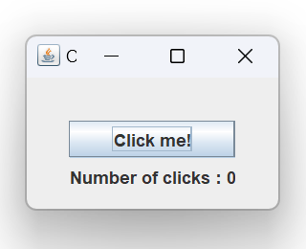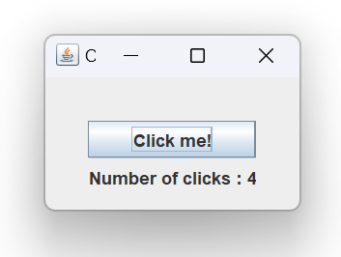

Fig 1.1: Output window.

**Explanation:**

In this code, Java is used to create Graphical User Interface or GUI for short. This code generates a simple window with a button for which on click the text below changes ie. The number of clicks increases.

**Problem No.**: 02

**Problem Name**: Login form, a GUI Project using Java.

**Code:**

import java.awt.event.ActionEvent;

import java.awt.event.ActionListener;

import javax.swing.JButton;

import javax.swing.JFrame;

import javax.swing.JLabel;

import javax.swing.JPanel;

import javax.swing.JPasswordField;

import javax.swing.JTextField;

public class GUI implements ActionListener{

private static JFrame frame;

private static JPanel panel;

private static JLabel UserLabel;

private static JButton button;

private static JLabel success;

private static JTextField userText;

private static JPasswordField passwordText;

public static void main(String[] args) {

frame = new JFrame();

panel = new JPanel();

frame.setSize(400,400);

frame.setDefaultCloseOperation(JFrame.EXIT_ON_CLOSE);

frame.add(panel);

panel.setLayout(null);

UserLabel = new JLabel("User");

UserLabel.setBounds(10, 20, 80, 25);

panel.add(UserLabel);

userText = new JTextField(20);

userText.setBounds(100,20,165,25);

panel.add(userText);

JLabel passwordLabel = new JLabel("Password");

passwordLabel.setBounds(10,50, 80, 25);

panel.add(passwordLabel);

passwordText = new JPasswordField();

passwordText.setBounds(100, 50, 165, 25);

panel.add(passwordText);

button = new JButton("Login");

button.setBounds(10,80,80, 25);

button.addActionListener(new GUI());

panel.add(button);

success = new JLabel("");

success.setBounds(10,110,300,25);

panel.add(success);

//success.setText

frame.setVisible(true);

}

@Override

public void actionPerformed(ActionEvent e) {

String user = userText.getText();

String password = passwordText.getText();

if(user.equals("Alex") && password.equals("1234")){

success.setText("Successfull login");

}

}

}

**Output:**

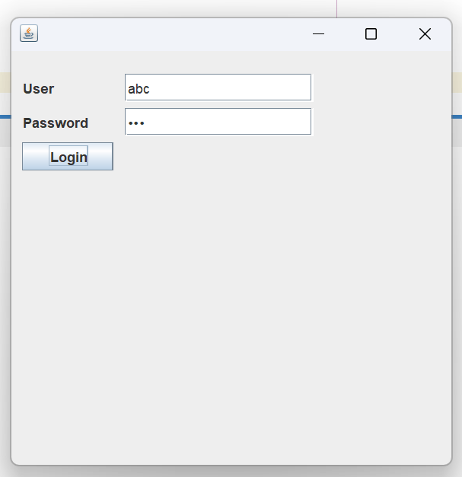

Fig 2.1: Output Window.

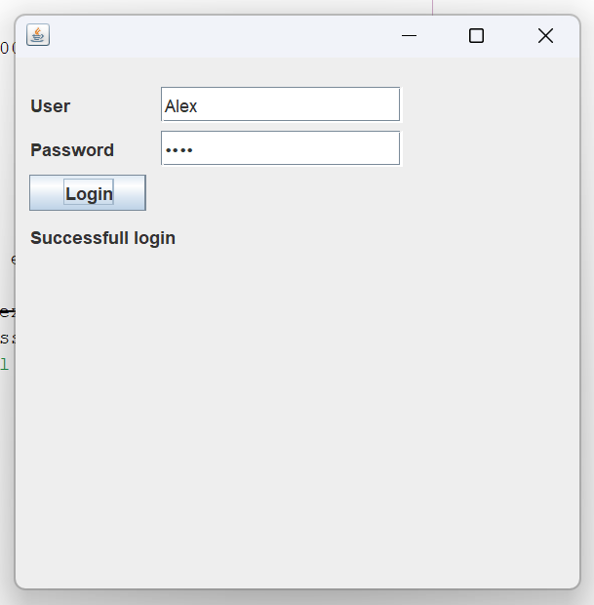

Fig 2.2: Output Window.

**Explanation:**

This code done in java is creates a login form window where if username is given “Alex” with “1234” being the password shows “Successful login”.

**Problem No.**: 03

**Problem Name**: Java project, Calculator.

**Code:**

/*

* Click nbfs://nbhost/SystemFileSystem/Templates/Licenses/license-default.txt to change this license

* Click nbfs://nbhost/SystemFileSystem/Templates/GUIForms/JFrame.java to edit this template

*/

package calc;

/**

*

* @author BAB AL SAFA

*/

public class calculator extends javax.swing.JFrame {

/**

* Creates new form calculator

*/

public calculator() {

initComponents();

}

public void disable(){

jTextField1.setEnabled(false);

jButton1.setEnabled(false);

jButton2.setEnabled(false);

jButton3.setEnabled(false);

jButton4.setEnabled(false);

jButton5.setEnabled(false);

jButton6.setEnabled(false);

jButton7.setEnabled(false);

jButton8.setEnabled(false);

jButton9.setEnabled(false);

jButton0.setEnabled(false);

jButtonBackspace.setEnabled(false);

jButtonDot.setEnabled(false);

jButtonEqual.setEnabled(false);

jButtonDevide.setEnabled(false);

jButtonMultiply.setEnabled(false);

jButtonMinus.setEnabled(false);

jButtonPlus.setEnabled(false);

jButtonClear.setEnabled(false);

}

public void enable(){

jTextField1.setEnabled(true);

jButton1.setEnabled(true);

jButton2.setEnabled(true);

jButton3.setEnabled(true);

jButton4.setEnabled(true);

jButton5.setEnabled(true);

jButton6.setEnabled(true);

jButton7.setEnabled(true);

jButton8.setEnabled(true);

jButton9.setEnabled(true);

jButton0.setEnabled(true);

jButtonBackspace.setEnabled(true);

jButtonDot.setEnabled(true);

jButtonEqual.setEnabled(true);

jButtonDevide.setEnabled(true);

jButtonMultiply.setEnabled(true);

jButtonMinus.setEnabled(true);

jButtonPlus.setEnabled(true);

jButtonClear.setEnabled(true);

}

/**

* This method is called from within the constructor to initialize the form.

* WARNING: Do NOT modify this code. The content of this method is always

* regenerated by the Form Editor.

*/

@SuppressWarnings("unchecked")

// <editor-fold defaultstate="collapsed" desc="Generated Code">

private void initComponents() {

jButton20 = new javax.swing.JButton();

jButton21 = new javax.swing.JButton();

buttonGroup1 = new javax.swing.ButtonGroup();

jTextField1 = new javax.swing.JTextField();

jRadioButtonON = new javax.swing.JRadioButton();

jRadioButtonOFF = new javax.swing.JRadioButton();

jButtonBackspace = new javax.swing.JButton();

jButtonClear = new javax.swing.JButton();

jButtonPlus = new javax.swing.JButton();

jButton1 = new javax.swing.JButton();

jButton2 = new javax.swing.JButton();

jButton3 = new javax.swing.JButton();

jButtonMultiply = new javax.swing.JButton();

jButtonDevide = new javax.swing.JButton();

jButton6 = new javax.swing.JButton();

jButton5 = new javax.swing.JButton();

jButton4 = new javax.swing.JButton();

jButton7 = new javax.swing.JButton();

jButton8 = new javax.swing.JButton();

jButton9 = new javax.swing.JButton();

jButtonEqual = new javax.swing.JButton();

jButtonDot = new javax.swing.JButton();

jButton0 = new javax.swing.JButton();

jButtonMinus = new javax.swing.JButton();

jButton20.setFont(new java.awt.Font("Tahoma", 1, 18)); // NOI18N

jButton20.setText("C");

jButton20.setToolTipText("");

jButton21.setFont(new java.awt.Font("Tahoma", 1, 18)); // NOI18N

jButton21.setText("C");

jButton21.setToolTipText("");

setDefaultCloseOperation(javax.swing.WindowConstants.EXIT_ON_CLOSE);

setTitle("Calculator");

setAlwaysOnTop(true);

setType(java.awt.Window.Type.UTILITY);

jTextField1.setEditable(false);

jTextField1.setFont(new java.awt.Font("Tahoma", 1, 24)); // NOI18N

jTextField1.setToolTipText("");

jTextField1.addActionListener(new java.awt.event.ActionListener() {

public void actionPerformed(java.awt.event.ActionEvent evt) {

jTextField1ActionPerformed(evt);

}

});

buttonGroup1.add(jRadioButtonON);

jRadioButtonON.setFont(new java.awt.Font("Tahoma", 1, 12)); // NOI18N

jRadioButtonON.setText("ON");

jRadioButtonON.setToolTipText("");

jRadioButtonON.addActionListener(new java.awt.event.ActionListener() {

public void actionPerformed(java.awt.event.ActionEvent evt) {

jRadioButtonONActionPerformed(evt);

}

});

buttonGroup1.add(jRadioButtonOFF);

jRadioButtonOFF.setFont(new java.awt.Font("Tahoma", 1, 12)); // NOI18N

jRadioButtonOFF.setText("OFF");

jRadioButtonOFF.setToolTipText("");

jRadioButtonOFF.addActionListener(new java.awt.event.ActionListener() {

public void actionPerformed(java.awt.event.ActionEvent evt) {

jRadioButtonOFFActionPerformed(evt);

}

});

jButtonBackspace.setFont(new java.awt.Font("Tahoma", 1, 14)); // NOI18N

jButtonBackspace.setText("<--");

jButtonBackspace.addActionListener(new java.awt.event.ActionListener() {

public void actionPerformed(java.awt.event.ActionEvent evt) {

jButtonBackspaceActionPerformed(evt);

}

});

jButtonClear.setFont(new java.awt.Font("Tahoma", 1, 18)); // NOI18N

jButtonClear.setText("C");

jButtonClear.setToolTipText("");

jButtonClear.addActionListener(new java.awt.event.ActionListener() {

public void actionPerformed(java.awt.event.ActionEvent evt) {

jButtonClearActionPerformed(evt);

}

});

jButtonPlus.setFont(new java.awt.Font("Tahoma", 1, 18)); // NOI18N

jButtonPlus.setText("+");

jButtonPlus.setToolTipText("");

jButtonPlus.addActionListener(new java.awt.event.ActionListener() {

public void actionPerformed(java.awt.event.ActionEvent evt) {

jButtonPlusActionPerformed(evt);

}

});

jButton1.setFont(new java.awt.Font("Tahoma", 1, 18)); // NOI18N

jButton1.setText("1");

jButton1.setToolTipText("");

jButton1.addActionListener(new java.awt.event.ActionListener() {

public void actionPerformed(java.awt.event.ActionEvent evt) {

jButton1ActionPerformed(evt);

}

});

jButton2.setFont(new java.awt.Font("Tahoma", 1, 18)); // NOI18N

jButton2.setText("2");

jButton2.setToolTipText("");

jButton2.addActionListener(new java.awt.event.ActionListener() {

public void actionPerformed(java.awt.event.ActionEvent evt) {

jButton2ActionPerformed(evt);

}

});

jButton3.setFont(new java.awt.Font("Tahoma", 1, 18)); // NOI18N

jButton3.setText("3");

jButton3.setToolTipText("");

jButton3.addActionListener(new java.awt.event.ActionListener() {

public void actionPerformed(java.awt.event.ActionEvent evt) {

jButton3ActionPerformed(evt);

}

});

jButtonMultiply.setFont(new java.awt.Font("Tahoma", 1, 18)); // NOI18N

jButtonMultiply.setText("*");

jButtonMultiply.setToolTipText("");

jButtonMultiply.addActionListener(new java.awt.event.ActionListener() {

public void actionPerformed(java.awt.event.ActionEvent evt) {

jButtonMultiplyActionPerformed(evt);

}

});

jButtonDevide.setFont(new java.awt.Font("Tahoma", 1, 18)); // NOI18N

jButtonDevide.setText("/");

jButtonDevide.setToolTipText("");

jButtonDevide.addActionListener(new java.awt.event.ActionListener() {

public void actionPerformed(java.awt.event.ActionEvent evt) {

jButtonDevideActionPerformed(evt);

}

});

jButton6.setFont(new java.awt.Font("Tahoma", 1, 18)); // NOI18N

jButton6.setText("6");

jButton6.setToolTipText("");

jButton6.addActionListener(new java.awt.event.ActionListener() {

public void actionPerformed(java.awt.event.ActionEvent evt) {

jButton6ActionPerformed(evt);

}

});

jButton5.setFont(new java.awt.Font("Tahoma", 1, 18)); // NOI18N

jButton5.setText("5");

jButton5.setToolTipText("");

jButton5.addActionListener(new java.awt.event.ActionListener() {

public void actionPerformed(java.awt.event.ActionEvent evt) {

jButton5ActionPerformed(evt);

}

});

jButton4.setFont(new java.awt.Font("Tahoma", 1, 18)); // NOI18N

jButton4.setText("4");

jButton4.setToolTipText("");

jButton4.addActionListener(new java.awt.event.ActionListener() {

public void actionPerformed(java.awt.event.ActionEvent evt) {

jButton4ActionPerformed(evt);

}

});

jButton7.setFont(new java.awt.Font("Tahoma", 1, 18)); // NOI18N

jButton7.setText("7");

jButton7.setToolTipText("");

jButton7.addActionListener(new java.awt.event.ActionListener() {

public void actionPerformed(java.awt.event.ActionEvent evt) {

jButton7ActionPerformed(evt);

}

});

jButton8.setFont(new java.awt.Font("Tahoma", 1, 18)); // NOI18N

jButton8.setText("8");

jButton8.setToolTipText("");

jButton8.addActionListener(new java.awt.event.ActionListener() {

public void actionPerformed(java.awt.event.ActionEvent evt) {

jButton8ActionPerformed(evt);

}

});

jButton9.setFont(new java.awt.Font("Tahoma", 1, 18)); // NOI18N

jButton9.setText("9");

jButton9.setToolTipText("");

jButton9.addActionListener(new java.awt.event.ActionListener() {

public void actionPerformed(java.awt.event.ActionEvent evt) {

jButton9ActionPerformed(evt);

}

});

jButtonEqual.setFont(new java.awt.Font("Tahoma", 1, 18)); // NOI18N

jButtonEqual.setText("=");

jButtonEqual.setToolTipText("");

jButtonEqual.addActionListener(new java.awt.event.ActionListener() {

public void actionPerformed(java.awt.event.ActionEvent evt) {

jButtonEqualActionPerformed(evt);

}

});

jButtonDot.setFont(new java.awt.Font("Tahoma", 1, 18)); // NOI18N

jButtonDot.setText(".");

jButtonDot.setToolTipText("");

jButtonDot.addActionListener(new java.awt.event.ActionListener() {

public void actionPerformed(java.awt.event.ActionEvent evt) {

jButtonDotActionPerformed(evt);

}

});

jButton0.setFont(new java.awt.Font("Tahoma", 1, 18)); // NOI18N

jButton0.setText("0");

jButton0.setToolTipText("");

jButton0.addActionListener(new java.awt.event.ActionListener() {

public void actionPerformed(java.awt.event.ActionEvent evt) {

jButton0ActionPerformed(evt);

}

});

jButtonMinus.setFont(new java.awt.Font("Tahoma", 1, 18)); // NOI18N

jButtonMinus.setText("-");

jButtonMinus.setToolTipText("");

jButtonMinus.addActionListener(new java.awt.event.ActionListener() {

public void actionPerformed(java.awt.event.ActionEvent evt) {

jButtonMinusActionPerformed(evt);

}

});

javax.swing.GroupLayout layout = new javax.swing.GroupLayout(getContentPane());

getContentPane().setLayout(layout);

layout.setHorizontalGroup(

layout.createParallelGroup(javax.swing.GroupLayout.Alignment.LEADING)

.addGroup(layout.createSequentialGroup()

.addContainerGap()

.addGroup(layout.createParallelGroup(javax.swing.GroupLayout.Alignment.LEADING)

.addGroup(layout.createSequentialGroup()

.addComponent(jButton4, javax.swing.GroupLayout.PREFERRED_SIZE, 51, javax.swing.GroupLayout.PREFERRED_SIZE)

.addPreferredGap(javax.swing.LayoutStyle.ComponentPlacement.RELATED, javax.swing.GroupLayout.DEFAULT_SIZE, Short.MAX_VALUE)

.addComponent(jButton5, javax.swing.GroupLayout.PREFERRED_SIZE, 51, javax.swing.GroupLayout.PREFERRED_SIZE)

.addPreferredGap(javax.swing.LayoutStyle.ComponentPlacement.RELATED)

.addComponent(jButton6, javax.swing.GroupLayout.PREFERRED_SIZE, 51, javax.swing.GroupLayout.PREFERRED_SIZE)

.addPreferredGap(javax.swing.LayoutStyle.ComponentPlacement.RELATED)

.addGroup(layout.createParallelGroup(javax.swing.GroupLayout.Alignment.LEADING)

.addGroup(layout.createSequentialGroup()

.addComponent(jButtonMinus, javax.swing.GroupLayout.PREFERRED_SIZE, 51, javax.swing.GroupLayout.PREFERRED_SIZE)

.addGap(0, 0, Short.MAX_VALUE))

.addGroup(layout.createSequentialGroup()

.addGroup(layout.createParallelGroup(javax.swing.GroupLayout.Alignment.LEADING)

.addGroup(javax.swing.GroupLayout.Alignment.TRAILING, layout.createSequentialGroup()

.addGap(0, 1, Short.MAX_VALUE)

.addComponent(jButtonMultiply, javax.swing.GroupLayout.PREFERRED_SIZE, 51, javax.swing.GroupLayout.PREFERRED_SIZE))

.addGroup(layout.createSequentialGroup()

.addComponent(jButtonDevide, javax.swing.GroupLayout.PREFERRED_SIZE, 51, javax.swing.GroupLayout.PREFERRED_SIZE)

.addGap(0, 0, Short.MAX_VALUE)))

.addContainerGap())))

.addGroup(layout.createSequentialGroup()

.addComponent(jButton0, javax.swing.GroupLayout.PREFERRED_SIZE, 51, javax.swing.GroupLayout.PREFERRED_SIZE)

.addPreferredGap(javax.swing.LayoutStyle.ComponentPlacement.RELATED)

.addComponent(jButtonDot, javax.swing.GroupLayout.PREFERRED_SIZE, 51, javax.swing.GroupLayout.PREFERRED_SIZE)

.addPreferredGap(javax.swing.LayoutStyle.ComponentPlacement.RELATED)

.addComponent(jButtonEqual, javax.swing.GroupLayout.PREFERRED_SIZE, 108, javax.swing.GroupLayout.PREFERRED_SIZE)

.addGap(0, 0, Short.MAX_VALUE))

.addGroup(layout.createSequentialGroup()

.addGroup(layout.createParallelGroup(javax.swing.GroupLayout.Alignment.LEADING)

.addGroup(layout.createSequentialGroup()

.addComponent(jButton1, javax.swing.GroupLayout.PREFERRED_SIZE, 51, javax.swing.GroupLayout.PREFERRED_SIZE)

.addPreferredGap(javax.swing.LayoutStyle.ComponentPlacement.RELATED)

.addComponent(jButton2, javax.swing.GroupLayout.PREFERRED_SIZE, 51, javax.swing.GroupLayout.PREFERRED_SIZE)

.addPreferredGap(javax.swing.LayoutStyle.ComponentPlacement.RELATED)

.addComponent(jButton3, javax.swing.GroupLayout.PREFERRED_SIZE, 51, javax.swing.GroupLayout.PREFERRED_SIZE))

.addGroup(layout.createSequentialGroup()

.addComponent(jButton7, javax.swing.GroupLayout.PREFERRED_SIZE, 51, javax.swing.GroupLayout.PREFERRED_SIZE)

.addPreferredGap(javax.swing.LayoutStyle.ComponentPlacement.RELATED)

.addComponent(jButton8, javax.swing.GroupLayout.PREFERRED_SIZE, 51, javax.swing.GroupLayout.PREFERRED_SIZE)

.addPreferredGap(javax.swing.LayoutStyle.ComponentPlacement.RELATED)

.addComponent(jButton9, javax.swing.GroupLayout.PREFERRED_SIZE, 51, javax.swing.GroupLayout.PREFERRED_SIZE)))

.addContainerGap(javax.swing.GroupLayout.DEFAULT_SIZE, Short.MAX_VALUE))

.addGroup(layout.createSequentialGroup()

.addGroup(layout.createParallelGroup(javax.swing.GroupLayout.Alignment.LEADING)

.addComponent(jTextField1, javax.swing.GroupLayout.Alignment.TRAILING)

.addGroup(layout.createSequentialGroup()

.addGroup(layout.createParallelGroup(javax.swing.GroupLayout.Alignment.LEADING)

.addComponent(jRadioButtonON)

.addComponent(jRadioButtonOFF))

.addPreferredGap(javax.swing.LayoutStyle.ComponentPlacement.RELATED, javax.swing.GroupLayout.DEFAULT_SIZE, Short.MAX_VALUE)

.addComponent(jButtonBackspace, javax.swing.GroupLayout.PREFERRED_SIZE, 53, javax.swing.GroupLayout.PREFERRED_SIZE)

.addPreferredGap(javax.swing.LayoutStyle.ComponentPlacement.RELATED)

.addComponent(jButtonClear, javax.swing.GroupLayout.PREFERRED_SIZE, 51, javax.swing.GroupLayout.PREFERRED_SIZE)

.addGap(8, 8, 8)

.addComponent(jButtonPlus, javax.swing.GroupLayout.PREFERRED_SIZE, 51, javax.swing.GroupLayout.PREFERRED_SIZE)

.addGap(0, 0, Short.MAX_VALUE)))

.addContainerGap())))

);

layout.setVerticalGroup(

layout.createParallelGroup(javax.swing.GroupLayout.Alignment.LEADING)

.addGroup(layout.createSequentialGroup()

.addGap(24, 24, 24)

.addComponent(jTextField1, javax.swing.GroupLayout.PREFERRED_SIZE, 53, javax.swing.GroupLayout.PREFERRED_SIZE)

.addGroup(layout.createParallelGroup(javax.swing.GroupLayout.Alignment.LEADING)

.addGroup(layout.createSequentialGroup()

.addPreferredGap(javax.swing.LayoutStyle.ComponentPlacement.RELATED)

.addComponent(jRadioButtonON)

.addPreferredGap(javax.swing.LayoutStyle.ComponentPlacement.RELATED)

.addComponent(jRadioButtonOFF)

.addPreferredGap(javax.swing.LayoutStyle.ComponentPlacement.RELATED, javax.swing.GroupLayout.DEFAULT_SIZE, Short.MAX_VALUE))

.addGroup(javax.swing.GroupLayout.Alignment.TRAILING, layout.createSequentialGroup()

.addPreferredGap(javax.swing.LayoutStyle.ComponentPlacement.RELATED, javax.swing.GroupLayout.DEFAULT_SIZE, Short.MAX_VALUE)

.addGroup(layout.createParallelGroup(javax.swing.GroupLayout.Alignment.TRAILING, false)

.addComponent(jButtonBackspace, javax.swing.GroupLayout.Alignment.LEADING, javax.swing.GroupLayout.DEFAULT_SIZE, javax.swing.GroupLayout.DEFAULT_SIZE, Short.MAX_VALUE)

.addGroup(layout.createParallelGroup(javax.swing.GroupLayout.Alignment.BASELINE)

.addComponent(jButtonClear)

.addComponent(jButtonPlus)))

.addPreferredGap(javax.swing.LayoutStyle.ComponentPlacement.UNRELATED)))

.addGroup(layout.createParallelGroup(javax.swing.GroupLayout.Alignment.LEADING)

.addComponent(jButtonMinus)

.addGroup(layout.createSequentialGroup()

.addGroup(layout.createParallelGroup(javax.swing.GroupLayout.Alignment.BASELINE)

.addComponent(jButton1)

.addComponent(jButton2)

.addComponent(jButton3))

.addPreferredGap(javax.swing.LayoutStyle.ComponentPlacement.RELATED)

.addGroup(layout.createParallelGroup(javax.swing.GroupLayout.Alignment.BASELINE)

.addComponent(jButton6)

.addComponent(jButton5)

.addComponent(jButton4)

.addComponent(jButtonMultiply))

.addPreferredGap(javax.swing.LayoutStyle.ComponentPlacement.RELATED)

.addGroup(layout.createParallelGroup(javax.swing.GroupLayout.Alignment.BASELINE)

.addComponent(jButton7)

.addComponent(jButton8)

.addComponent(jButton9)

.addComponent(jButtonDevide))))

.addPreferredGap(javax.swing.LayoutStyle.ComponentPlacement.RELATED)

.addGroup(layout.createParallelGroup(javax.swing.GroupLayout.Alignment.BASELINE)

.addComponent(jButtonEqual)

.addComponent(jButtonDot)

.addComponent(jButton0))

.addContainerGap())

);

pack();

}// </editor-fold>

private void jButtonBackspaceActionPerformed(java.awt.event.ActionEvent evt) {

// TODO add your handling code here:

}

private void jButton1ActionPerformed(java.awt.event.ActionEvent evt) {

jTextField1.setText(jTextField1.getText()+"1");

}

private void jButton3ActionPerformed(java.awt.event.ActionEvent evt) {

jTextField1.setText(jTextField1.getText()+"3");

}

private void jButton5ActionPerformed(java.awt.event.ActionEvent evt) {

jTextField1.setText(jTextField1.getText()+"5");

}

private void jButton7ActionPerformed(java.awt.event.ActionEvent evt) {

jTextField1.setText(jTextField1.getText()+"7");

}

private void jRadioButtonOFFActionPerformed(java.awt.event.ActionEvent evt) {

disable();

}

private void jTextField1ActionPerformed(java.awt.event.ActionEvent evt) {

// TODO add your handling code here:

}

private void jButton6ActionPerformed(java.awt.event.ActionEvent evt) {

jTextField1.setText(jTextField1.getText()+"6");

}

private void jButton2ActionPerformed(java.awt.event.ActionEvent evt) {

jTextField1.setText(jTextField1.getText()+"2");

}

private void jButton4ActionPerformed(java.awt.event.ActionEvent evt) {

jTextField1.setText(jTextField1.getText()+"4");

}

private void jButton8ActionPerformed(java.awt.event.ActionEvent evt) {

jTextField1.setText(jTextField1.getText()+"8");

}

private void jButton9ActionPerformed(java.awt.event.ActionEvent evt) {

jTextField1.setText(jTextField1.getText()+"9");

}

private void jButton0ActionPerformed(java.awt.event.ActionEvent evt) {

jTextField1.setText(jTextField1.getText()+"0");

}

private void jButtonDotActionPerformed(java.awt.event.ActionEvent evt) {

jTextField1.setText(jTextField1.getText()+".");

}

private void jButtonEqualActionPerformed(java.awt.event.ActionEvent evt) {

// TODO add your handling code here:

}

private void jButtonDevideActionPerformed(java.awt.event.ActionEvent evt) {

jTextField1.setText(jTextField1.getText()+"/");

}

private void jButtonMultiplyActionPerformed(java.awt.event.ActionEvent evt) {

jTextField1.setText(jTextField1.getText()+"*");

}

private void jButtonMinusActionPerformed(java.awt.event.ActionEvent evt) {

jTextField1.setText(jTextField1.getText()+"-");

}

private void jButtonPlusActionPerformed(java.awt.event.ActionEvent evt) {

jTextField1.setText(jTextField1.getText()+"+");

}

private void jButtonClearActionPerformed(java.awt.event.ActionEvent evt) {

jTextField1.setText("");

}

private void jRadioButtonONActionPerformed(java.awt.event.ActionEvent evt) {

enable();

}

/**

* @param args the command line arguments

*/

public static void main(String args[]) {

/* Set the Nimbus look and feel */

//<editor-fold defaultstate="collapsed" desc=" Look and feel setting code (optional) ">

/* If Nimbus (introduced in Java SE 6) is not available, stay with the default look and feel.

* For details see http://download.oracle.com/javase/tutorial/uiswing/lookandfeel/plaf.html

*/

try {

for (javax.swing.UIManager.LookAndFeelInfo info : javax.swing.UIManager.getInstalledLookAndFeels()) {

if ("Nimbus".equals(info.getName())) {

javax.swing.UIManager.setLookAndFeel(info.getClassName());

break;

}

}

} catch (ClassNotFoundException ex) {

java.util.logging.Logger.getLogger(calculator.class.getName()).log(java.util.logging.Level.SEVERE, null, ex);

} catch (InstantiationException ex) {

java.util.logging.Logger.getLogger(calculator.class.getName()).log(java.util.logging.Level.SEVERE, null, ex);

} catch (IllegalAccessException ex) {

java.util.logging.Logger.getLogger(calculator.class.getName()).log(java.util.logging.Level.SEVERE, null, ex);

} catch (javax.swing.UnsupportedLookAndFeelException ex) {

java.util.logging.Logger.getLogger(calculator.class.getName()).log(java.util.logging.Level.SEVERE, null, ex);

}

//</editor-fold>

/* Create and display the form */

java.awt.EventQueue.invokeLater(new Runnable() {

public void run() {

new calculator().setVisible(true);

}

});

}

// Variables declaration - do not modify

private javax.swing.ButtonGroup buttonGroup1;

private javax.swing.JButton jButton0;

private javax.swing.JButton jButton1;

private javax.swing.JButton jButton2;

private javax.swing.JButton jButton20;

private javax.swing.JButton jButton21;

private javax.swing.JButton jButton3;

private javax.swing.JButton jButton4;

private javax.swing.JButton jButton5;

private javax.swing.JButton jButton6;

private javax.swing.JButton jButton7;

private javax.swing.JButton jButton8;

private javax.swing.JButton jButton9;

private javax.swing.JButton jButtonBackspace;

private javax.swing.JButton jButtonClear;

private javax.swing.JButton jButtonDevide;

private javax.swing.JButton jButtonDot;

private javax.swing.JButton jButtonEqual;

private javax.swing.JButton jButtonMinus;

private javax.swing.JButton jButtonMultiply;

private javax.swing.JButton jButtonPlus;

private javax.swing.JRadioButton jRadioButtonOFF;

private javax.swing.JRadioButton jRadioButtonON;

private javax.swing.JTextField jTextField1;

// End of variables declaration

}

**Output:**

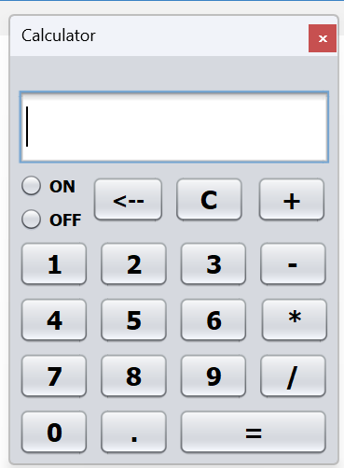

Fig 3.1: Output window.

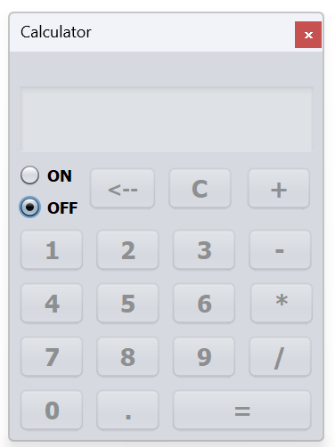

Fig 3.2: Output window.

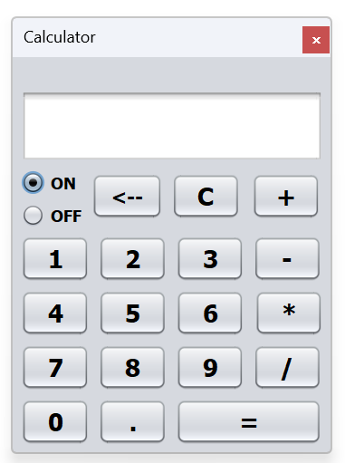

Fig 3.3: Output window.

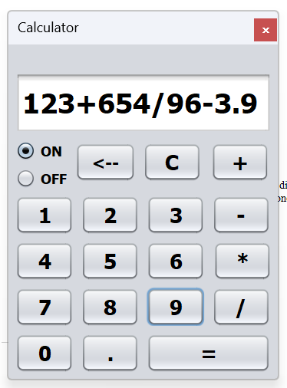

Fig 3.4: Output window.

**Explanation:**

The code is creates a GUI calculator window that can only display numbers.

On click on the number pad the display field would concatenate and display the numbers.